Table of Contents

Azure B2C Spike 2

Overview 2

B2C overview 2

B2C accounts 2

Identity experience – Policy type 2

Spike creation process 2

Register Azure AD to the Subscription 3

Create Azure AD B2C tenant 3

Register the Web App 4

Create user flow for the Web App – Sign up and Sign in 6

Create user flow for the Web App – Profile editing 7

Register the Web API 8

Configure scopes for the Web API 8

Grant permission for Web API 10

Running spike application locally 11

Testing the spike application 12

Next steps 13

# Azure B2C Spike

## Overview

This is a spike document on using Azure B2C AuthN and AuthZ of a web application in React calling an Azure B2C protected API endpoint.

The react sample uses MSAL React and MSAL Browser node packages. MSAL is a Microsoft library and simplifies the AuthN and AuthZ processes.

This spike shows the following:

1. Creation of Azure AD B2C tenant
2. Registration of SPA app in the B2C tenant
3. Registration of Web API in the B2C tenant
4. Sign in flow
5. Sign out flow
6. Calling an Azure B2C protected endpoint API

Note: The AD B2C is created on my own Azure subscription and the spike code is on my personal github account.

## B2C overview

### B2C accounts

AZ B2C has these account types:

1. Work account – these users can manage resources in a tenant, and also manage tenants if has administrator role. Can create new consumer accounts, reset passwords, block/unblock accounts, and set permissions or assign an account to a security group.
2. Group account – these users invited to your tenant as guests. E.g., inviting guest to the tenant to share administration responsibilities.
3. Consumer account – these users are managed by AZ B2C user flows and custom policies.

In this spike the focus is to allow a user to register into a sample web application that

### Identity experience – Policy type

There are two types of identity experience in AZ B2C, user flows and custom policies. User flows are predefined, built-in, configurable polies such as sign-up, sign-in and profile editing. While custom policies on the other hand enables you to create your own user journeys for complex identity scenarios. This spike focuses on user flows.

## Spike creation process

### Register Azure AD to the Subscription

1. Sign to Azure portal (<https://portal.azure.com>).
2. Make sure that `Microsoft.AzureActiveDirectory` is registered on the subscription.
   1. Switch to directory that is using Azure AD.

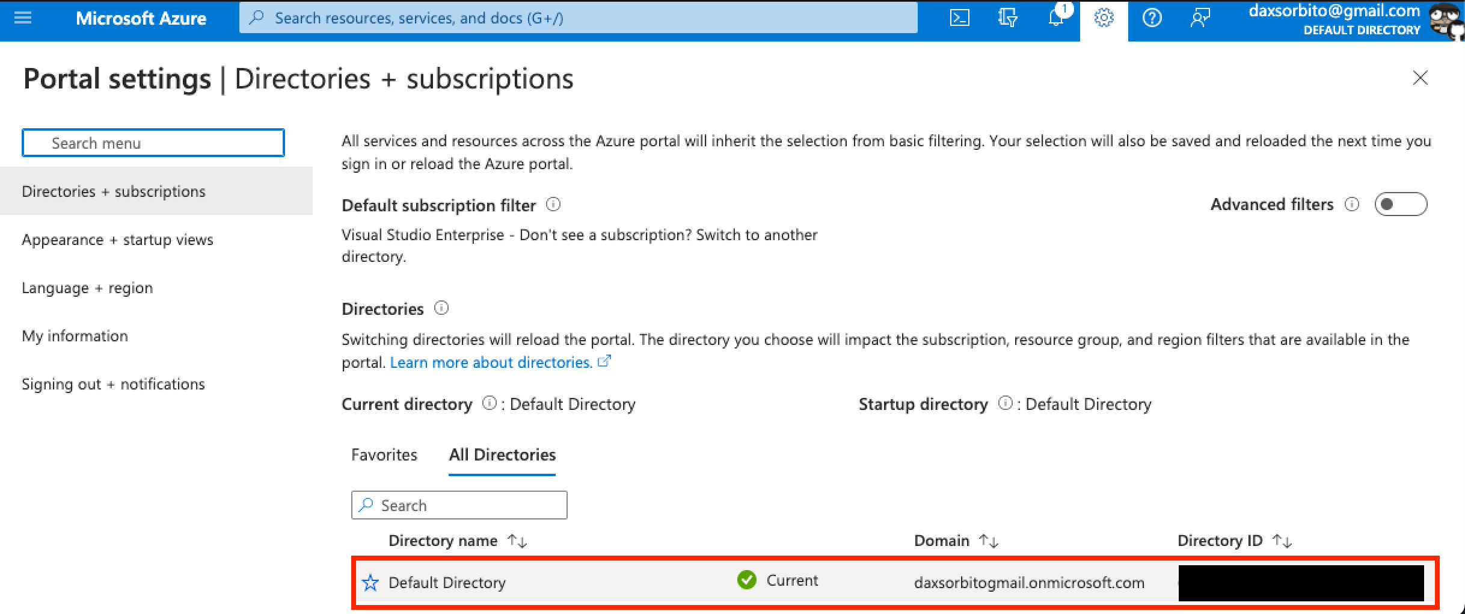

* 1. Select the subscription to use.

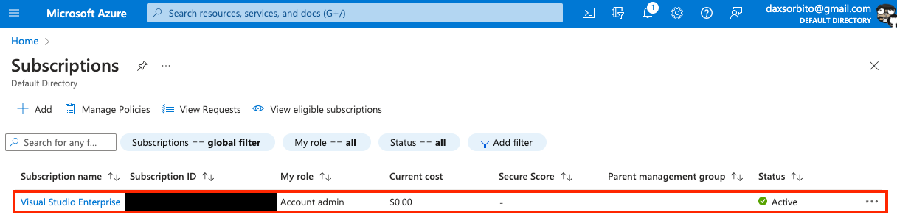

* 1. Go to the selected subscription’s `Settings` > `Resource providers` and search for `Microsoft.AzureActiveDirectory` and make sure it is `Registered`.

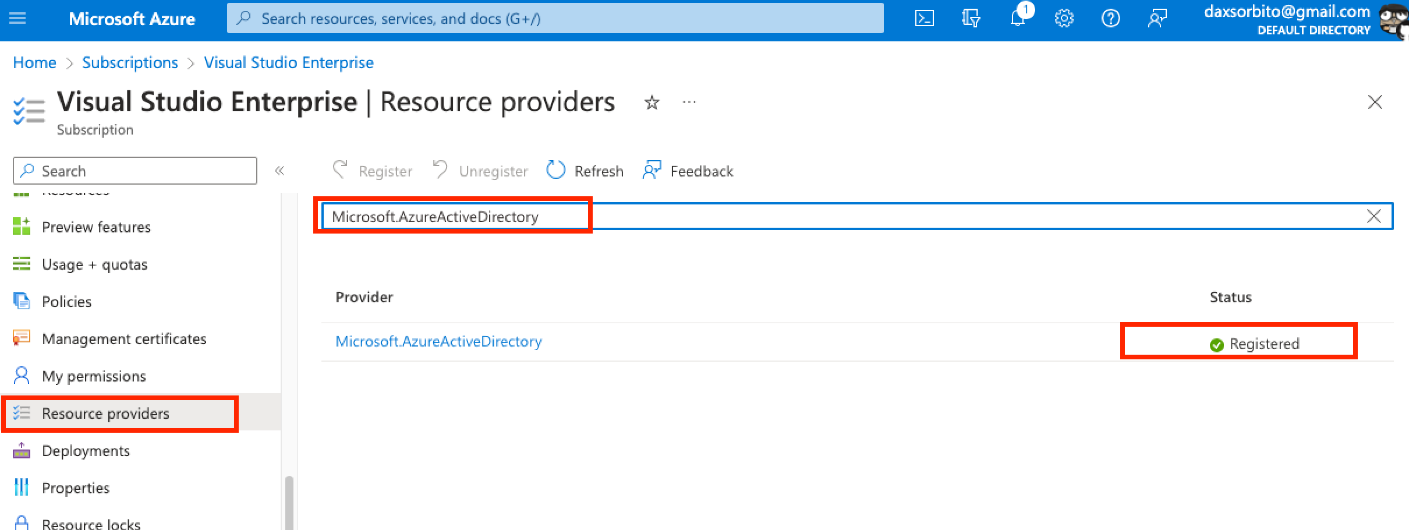

### Create Azure AD B2C tenant

1. Search for `b2c` on the portal search and select the `Azure Active Directory B2C` in the `Marketplace` suggestion dropdown.

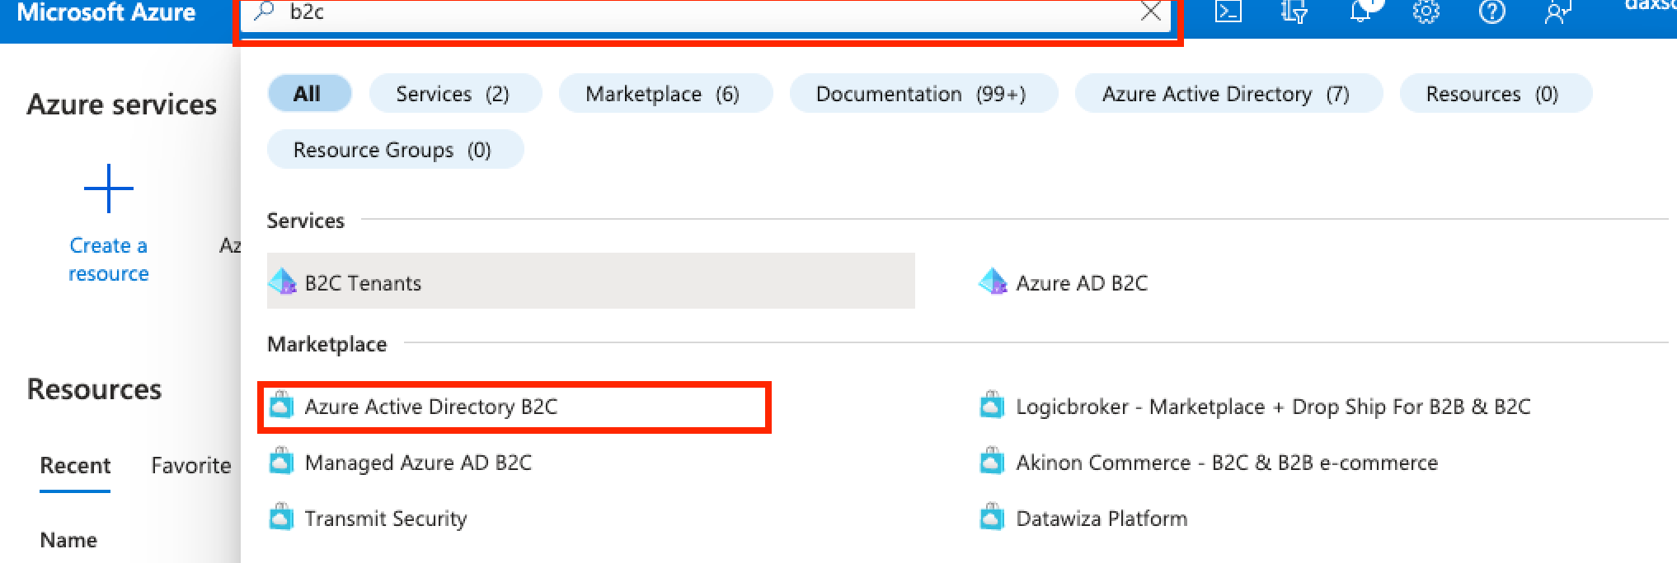

1. Select the `Create a new Azure AD B2C Tenant` option

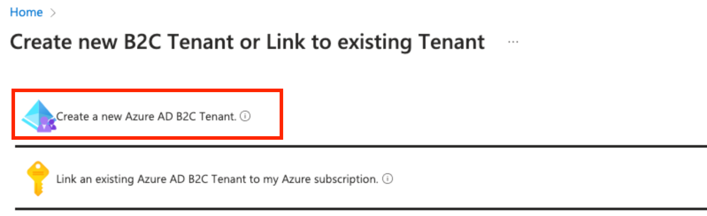

1. Then create a new tenant. For this spike, below are the information supplied. Note on the location, if the country/region selected has a `Go-Local add-on option` additional cost may be charged (see this link [Azure AD B2C: Region availability & data residency - Azure AD B2C | Microsoft Learn](https://learn.microsoft.com/en-gb/azure/active-directory-b2c/data-residency#go-local-add-on)). Then once the information is supplied click `Review + Create` then `Create`.

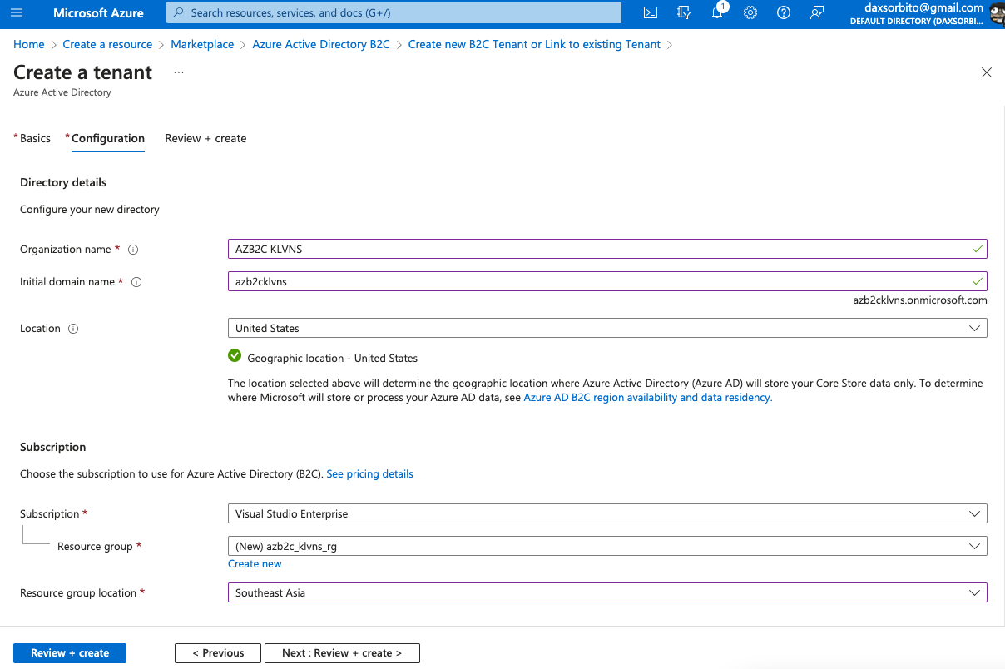

### Register the Web App

1. Switch directory to the newly created tenant.

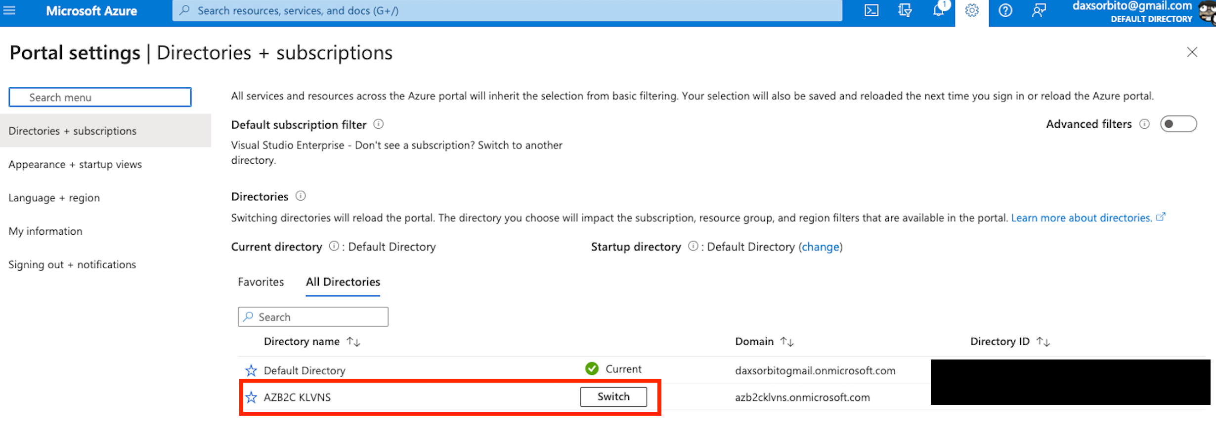

1. Search for `Azure AD B2C` on search portal and select it.

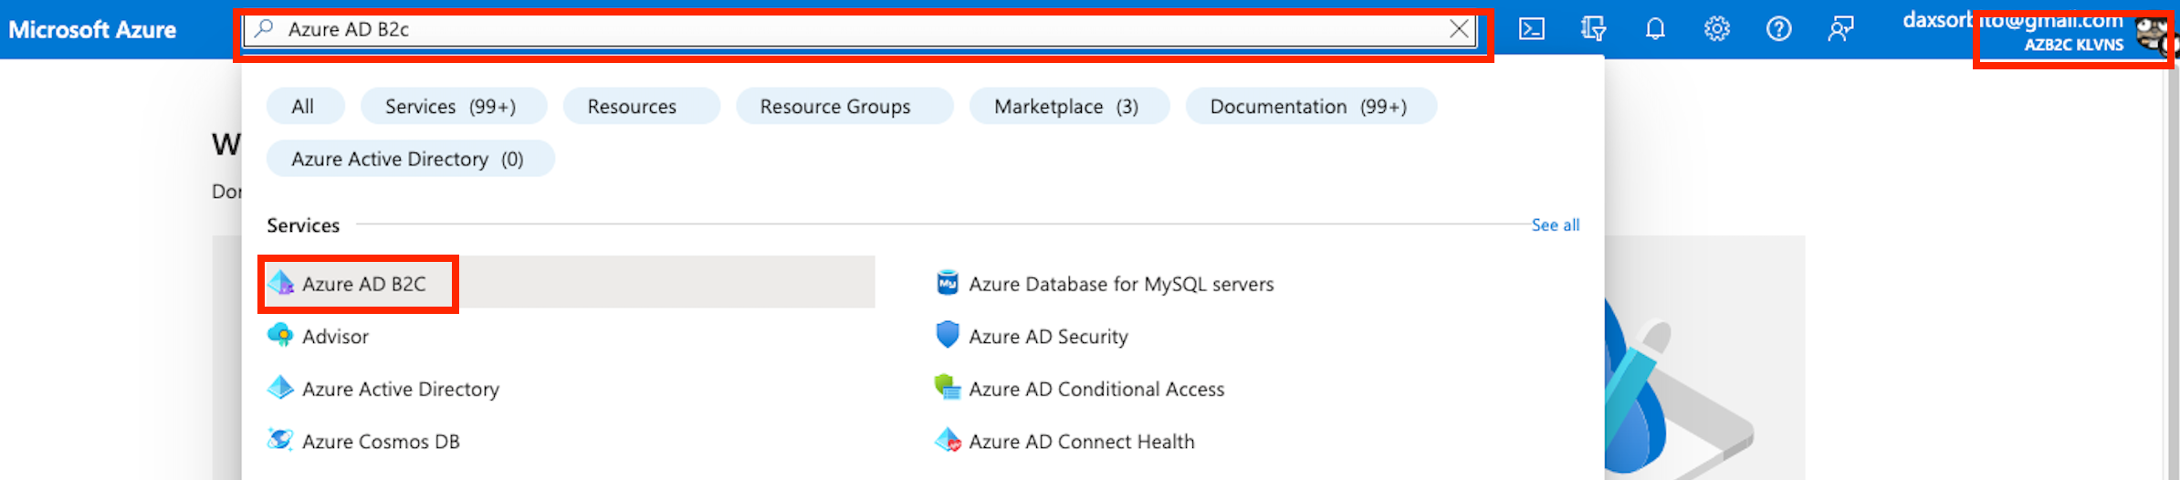

1. Under `Manage`, select `App registrations`, and then select `New registration`

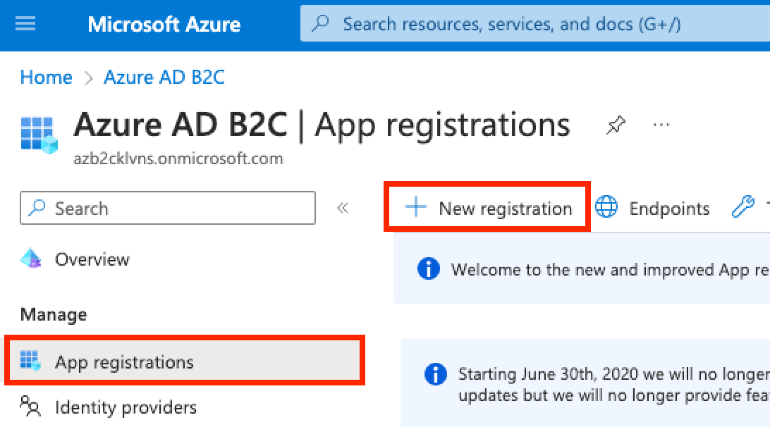

1. Register a new application, for this spike, these data were supplied. On URL box of the `Redirect URI`, info placed here is `http://localhost:3000` in an assumption that the react app web application is launched locally.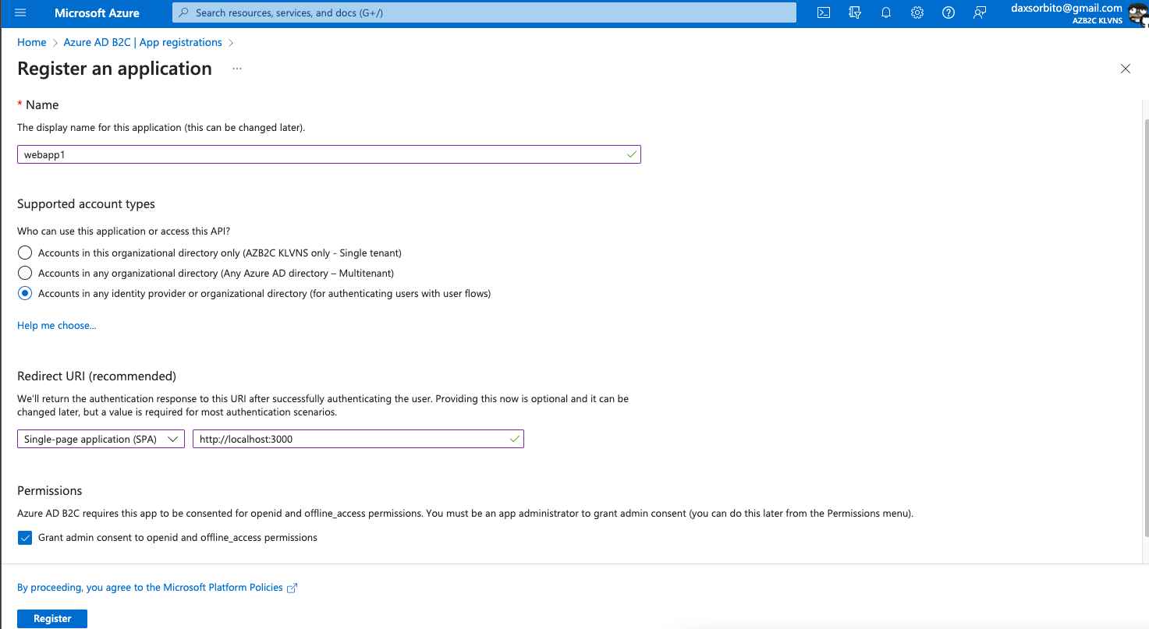
2. Then click `Register`.
3. Once done, take note of the `Application (client) ID` value to be used in a later step when the web application would be configured.

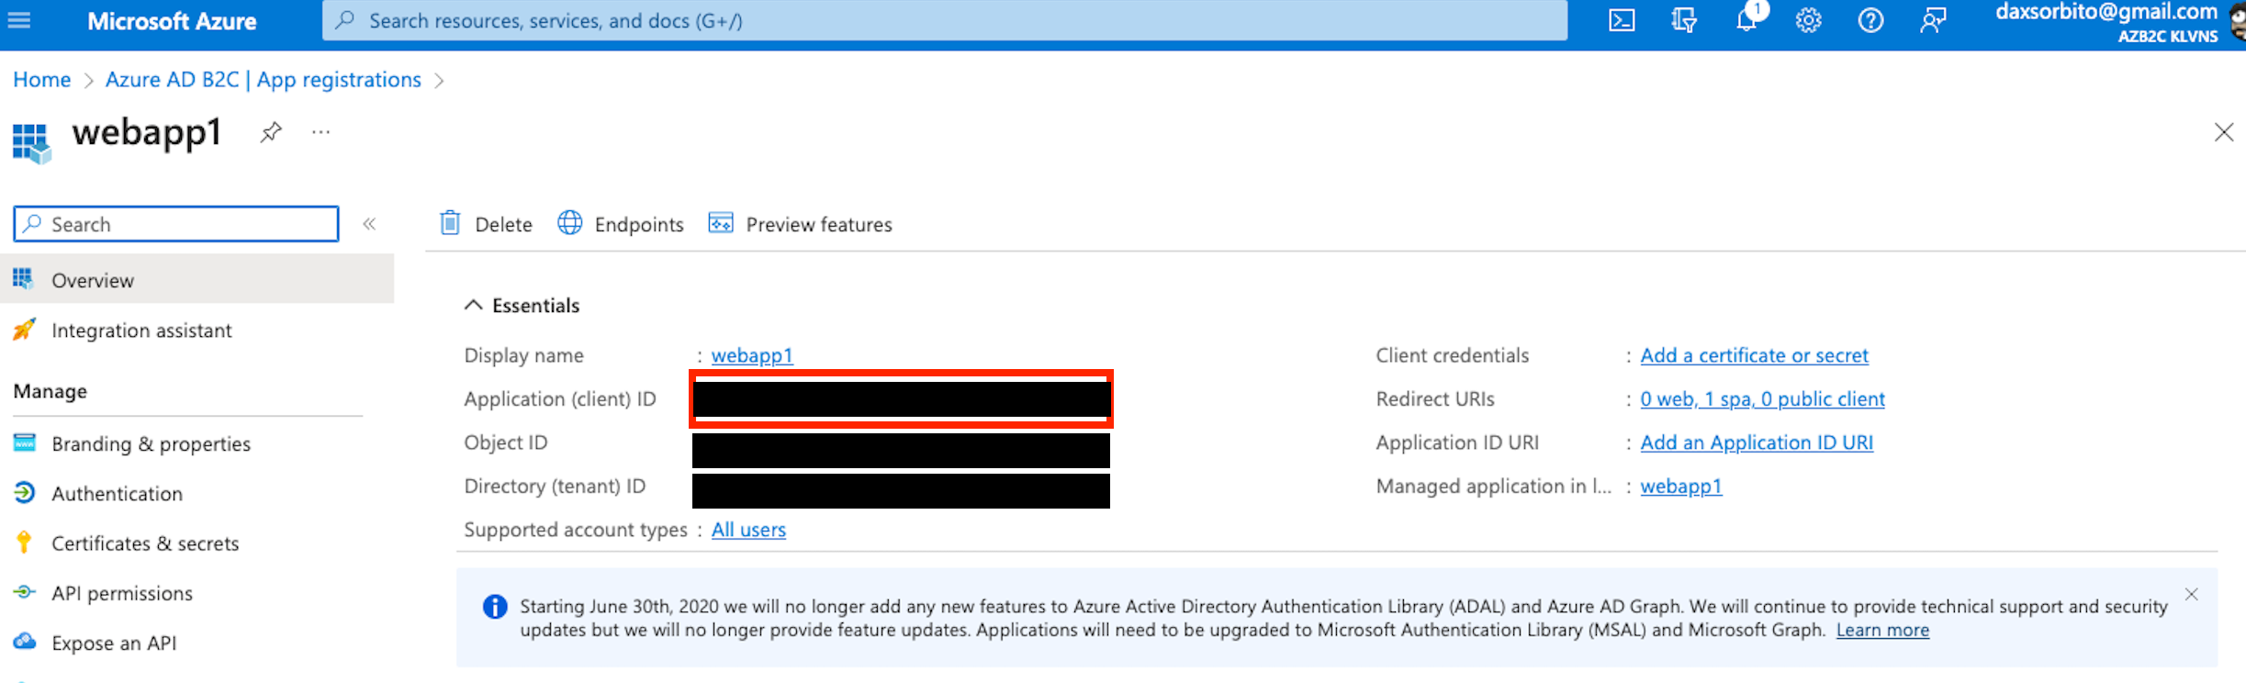

1. Create a client secret by selecting the `Certificates & secrets` under the `Manage` menu. Then click the `New client secret` and then data below were supplied on the `Add a client secret` pane.

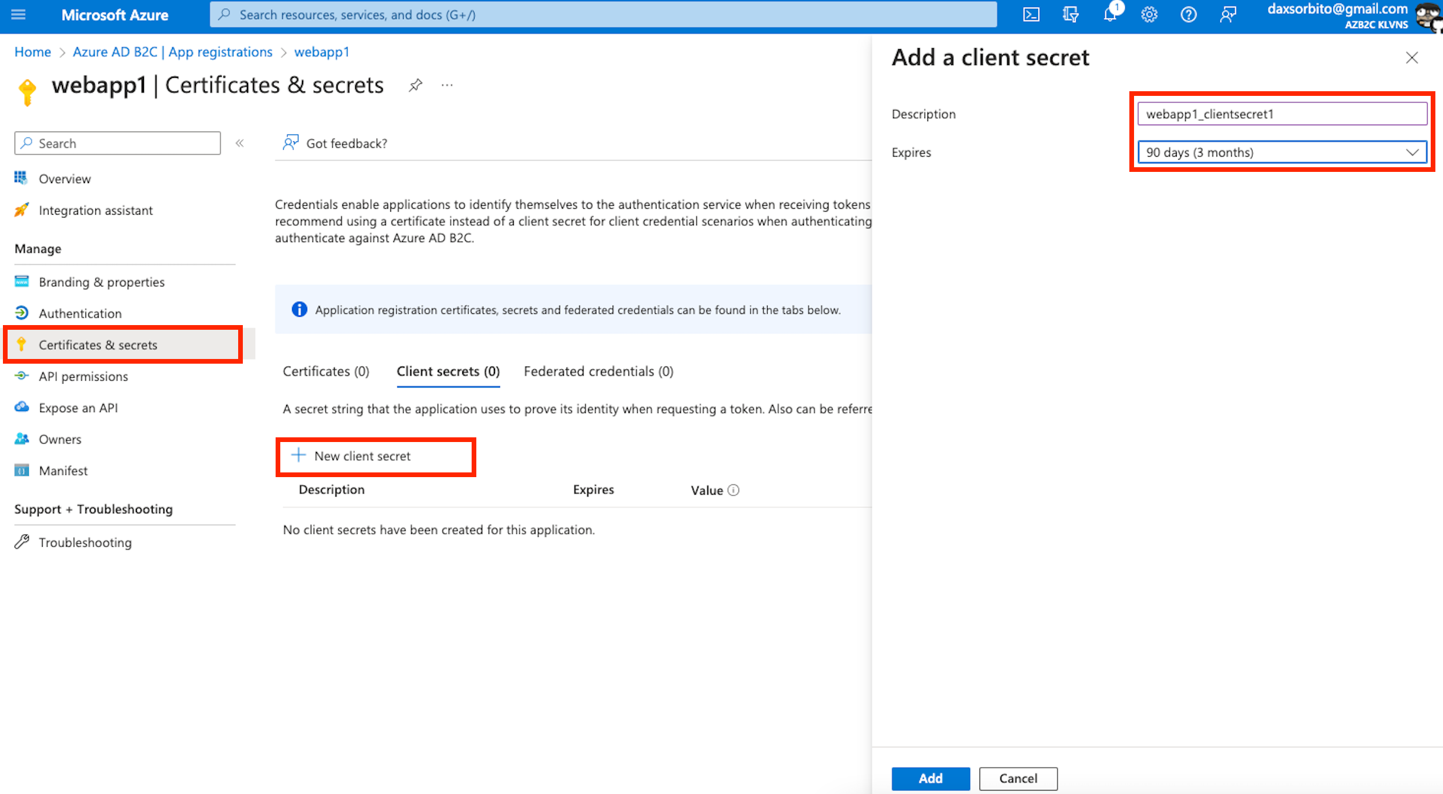

1. Then click `Add`, once done take note of the secret’s value, to be used in a later step when the web application would be configured.

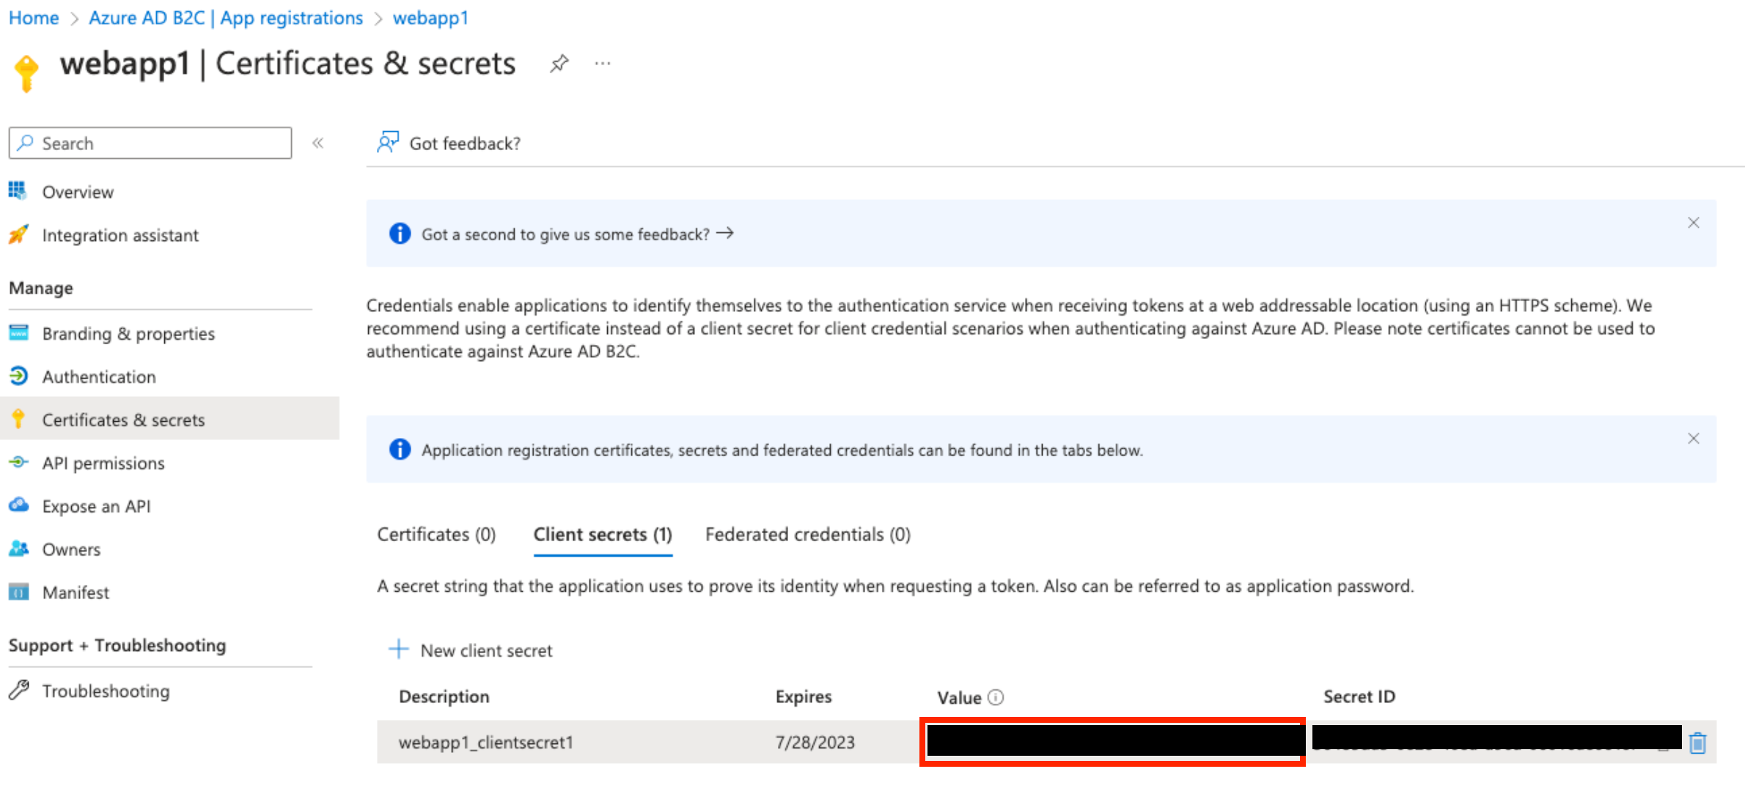

### Create user flow for the Web App – Sign up and Sign in

1. Search for `Azure AD B2C` on search portal and select it.



1. Once selected, click the `User flows` under `Policies`, then click `New user flow`.

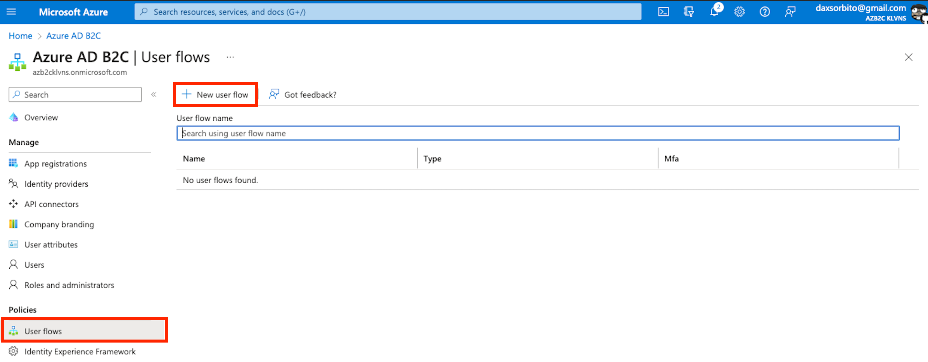

1. Select `Sign up and sign in` user flow type and `Recommended` for version. Then click `Create`.

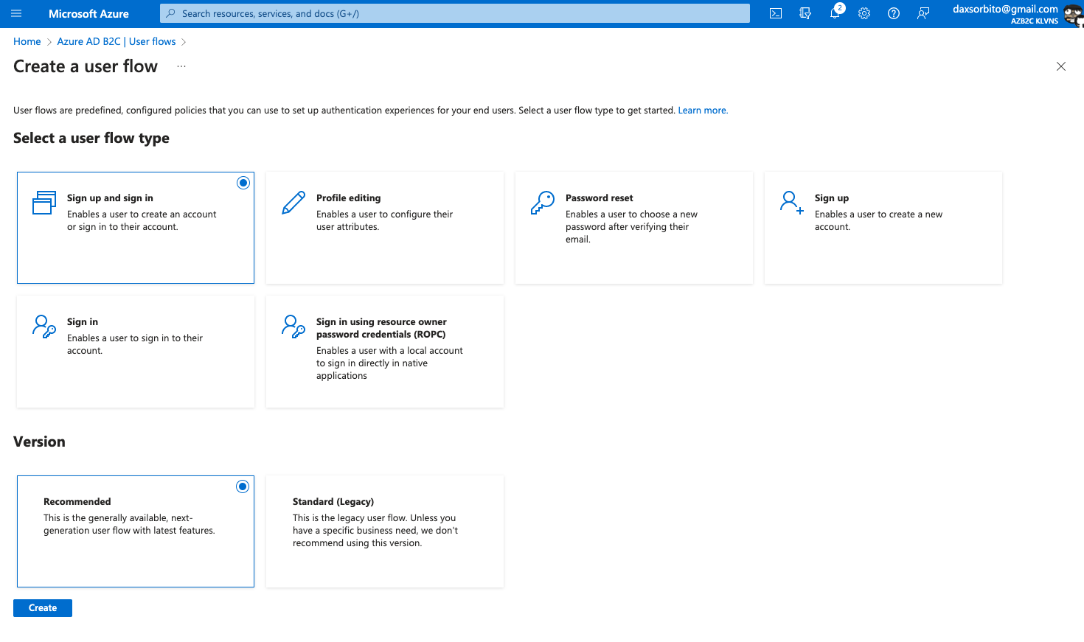

1. The data below were supplied on the `Create` page. Click `Ok` on the `Create` pane, then click `Create`.

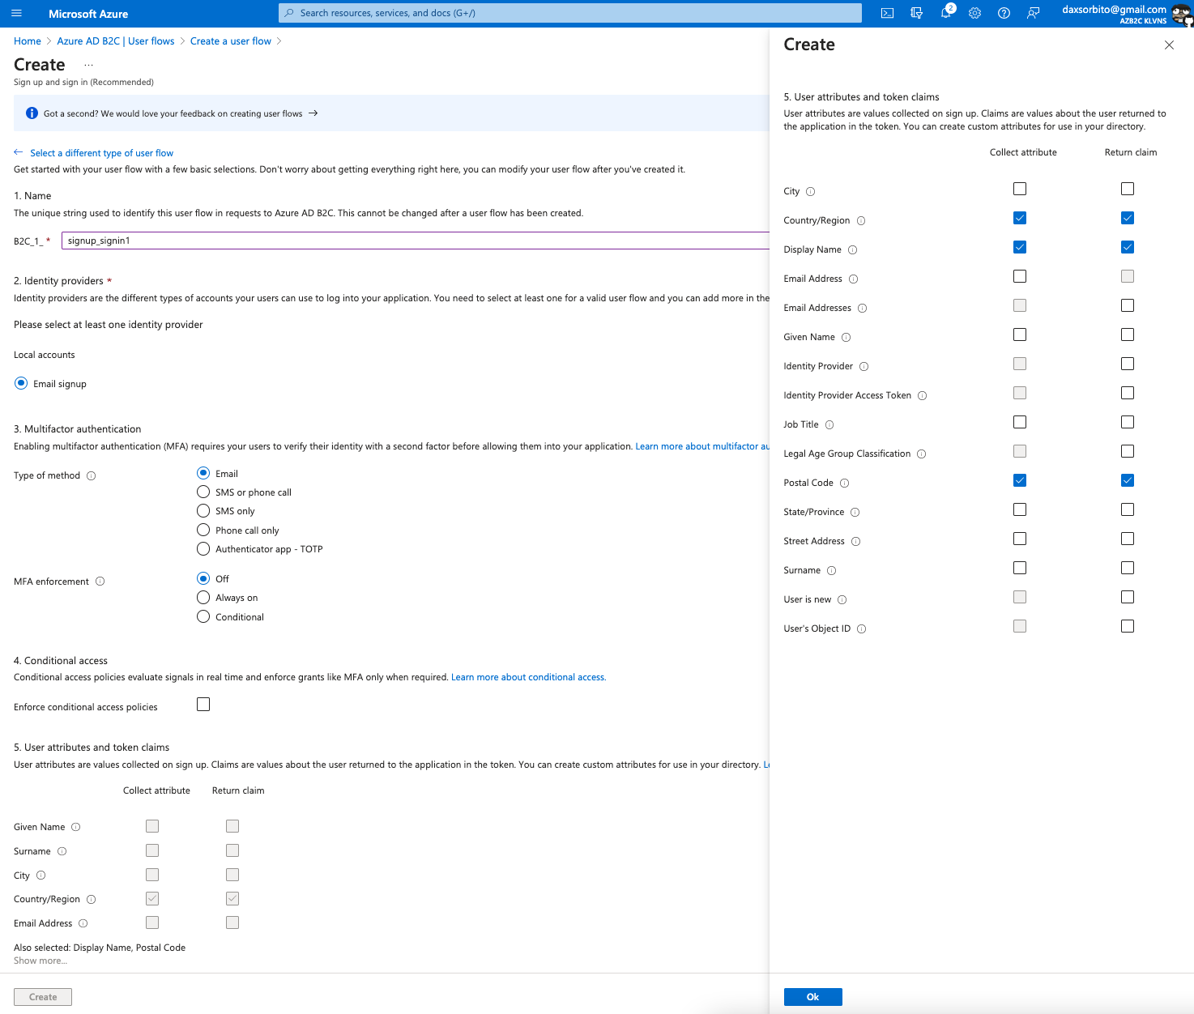

### Create user flow for the Web App – Profile editing

1. On the selected `Azure AD B2C`, click `User flows` under `Policies`, then click `New user flow`.

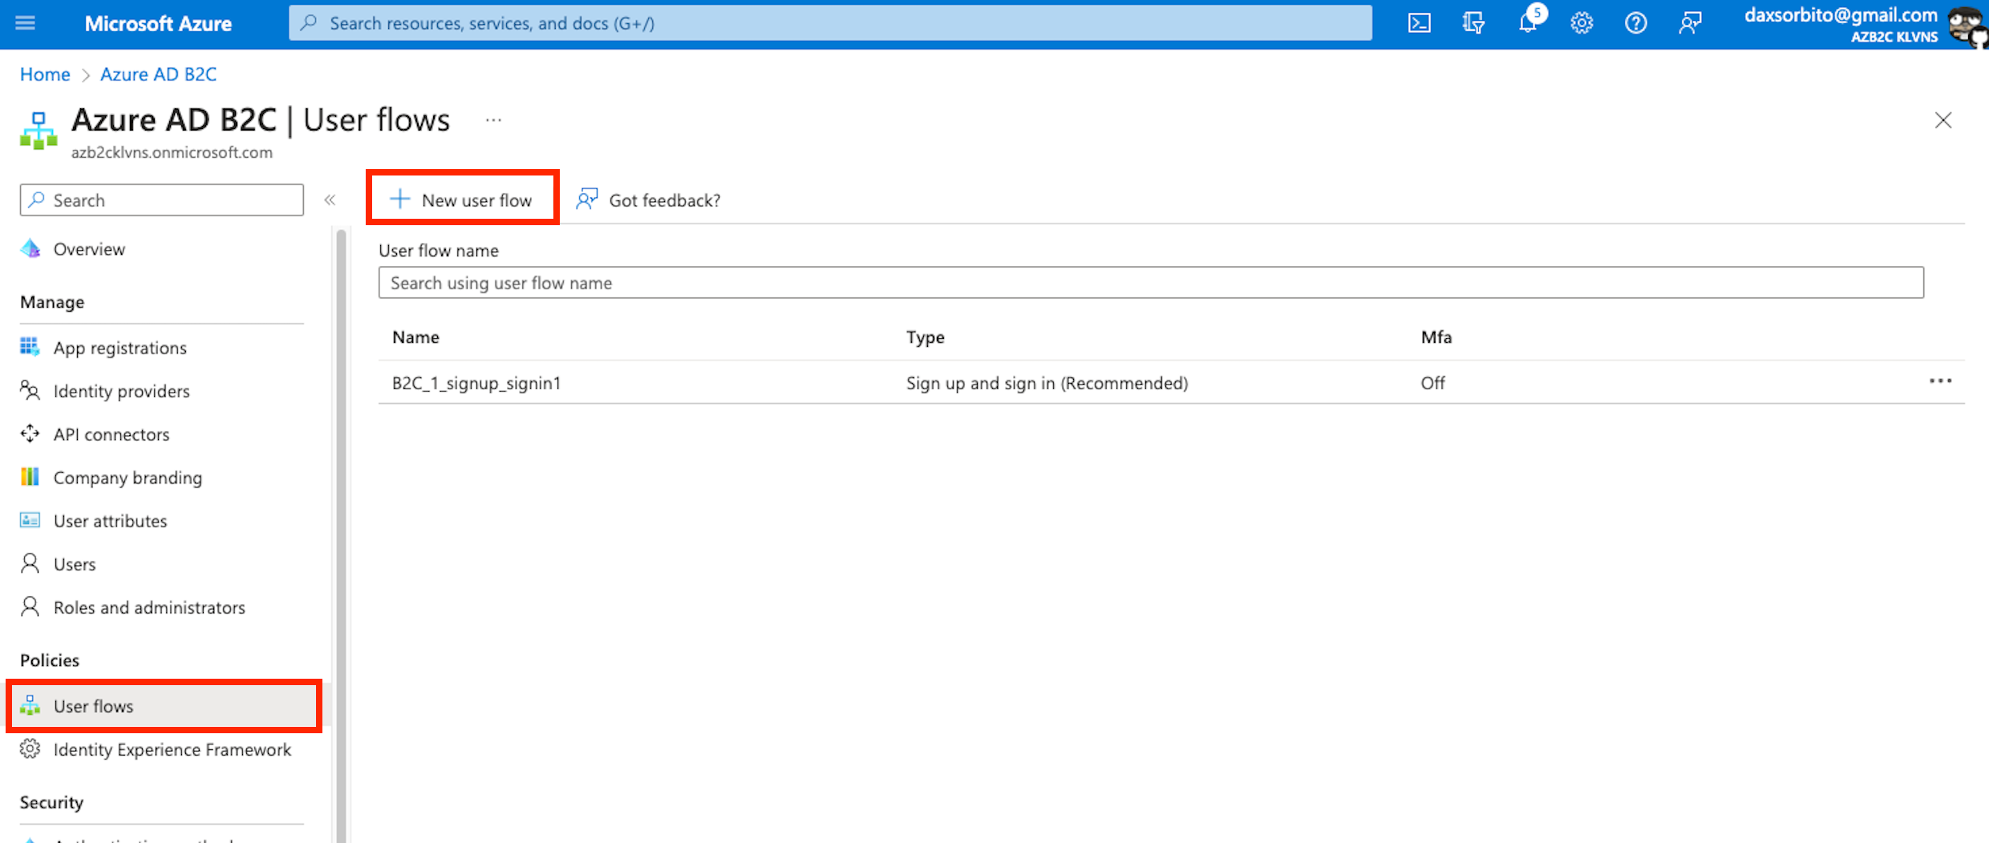

1. Select `Profile editing` user flow type and `Recommended` for version. Then click `Create`.

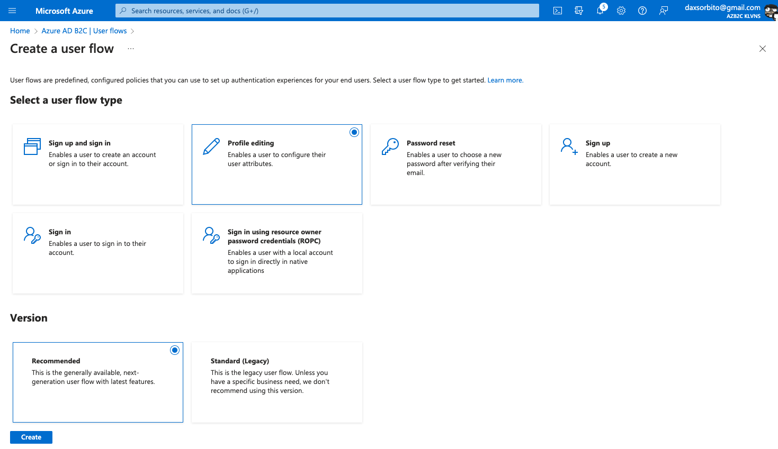

1. The data below were supplied on the `Create` page. Click `Ok` on the `Create` pane, then click `Create`.

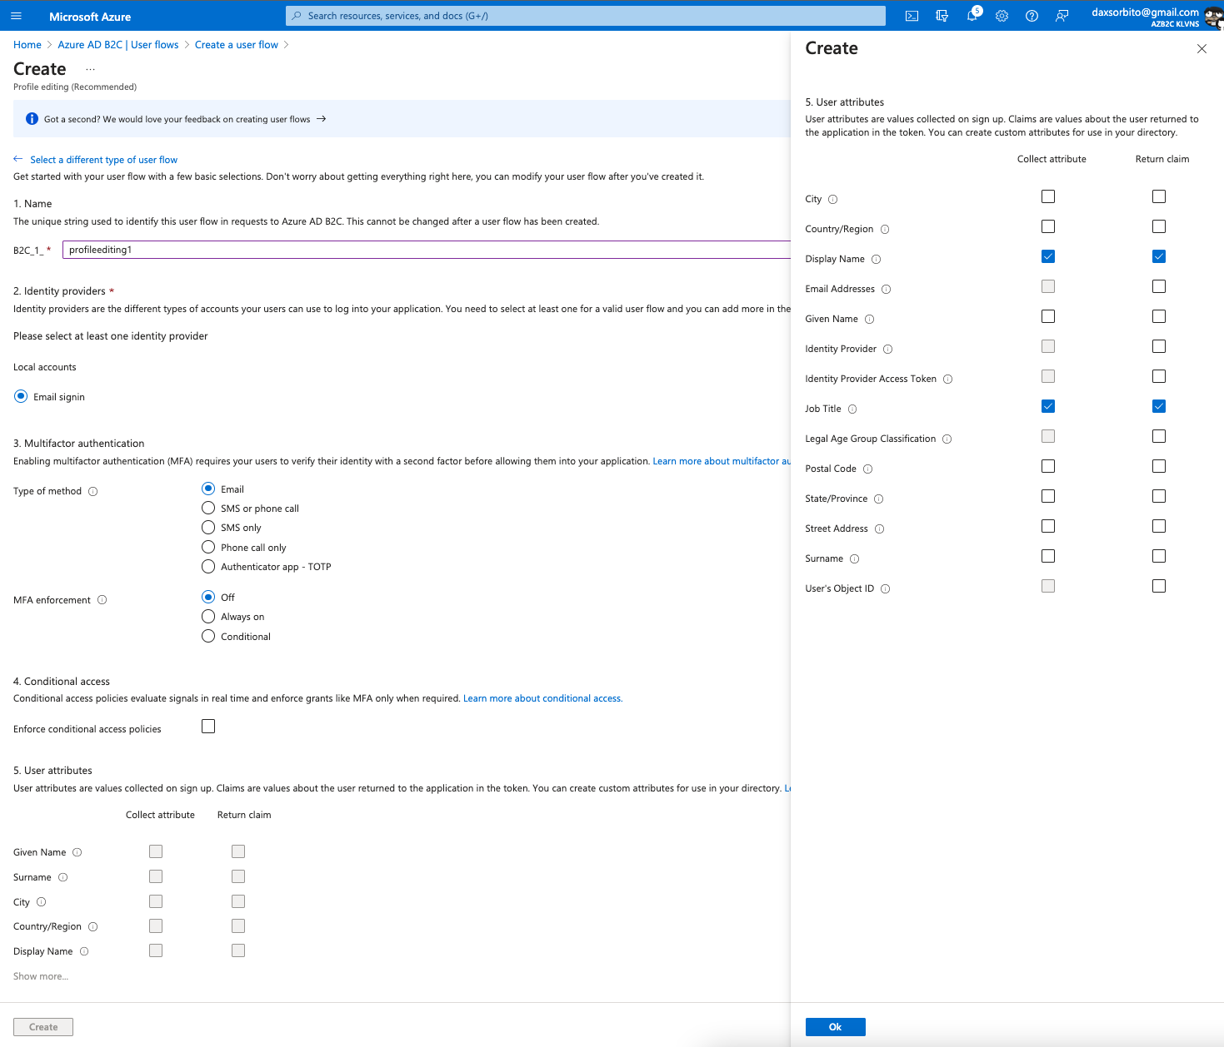

### Register the Web API

1. Follow the `Register the Web App` section of this document but replace the following.
   1. `Name` would be `api1`.
   2. Leave the default values for `Supported account types` and `Redirect URI`.
2. Then click `Register`.
3. Once done, take note of the `Application (client) ID` value to be used in a later step when the web API would be configured.

### Configure scopes for the Web API

1. On the newly created `App registration` of Web API, select `Expose and API` under `Manage`.

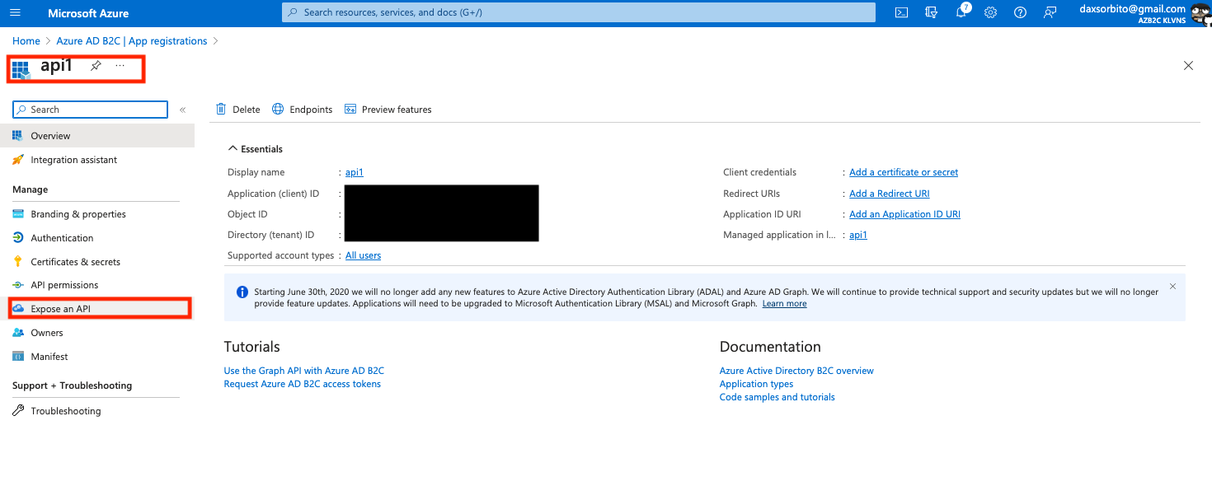

1. Click the `Set`.

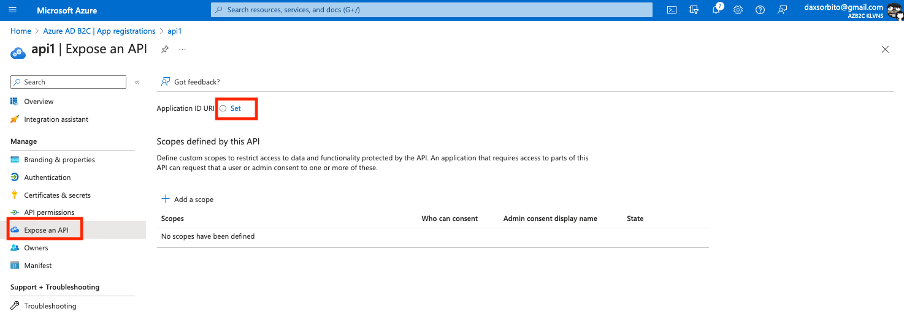

1. Replace the default value with `tasks-api`, the click `Save`.

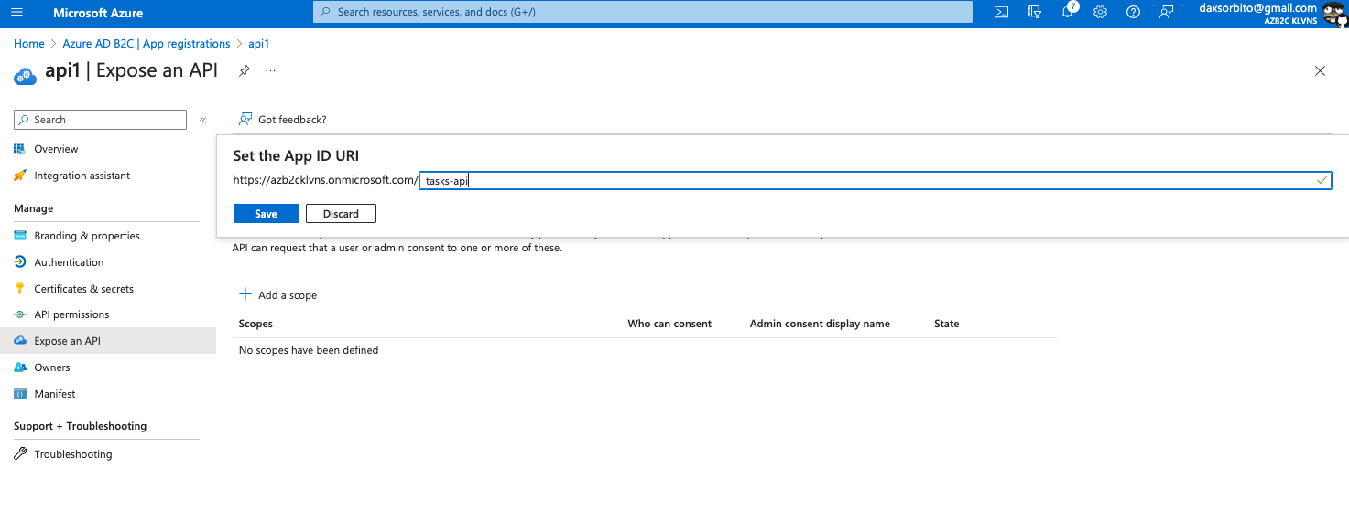

1. Add a scope `read` scope by clicking `Add a scope`. The following data was supplied on the `Add a scope` blade, and then click the `Add scope`.
   1. `Scope name` is `tasks.read`.
   2. `Admin consent display name` is `Read access to tasks API`.
   3. `Admin consent description` is `Allows read access to tasks API`.

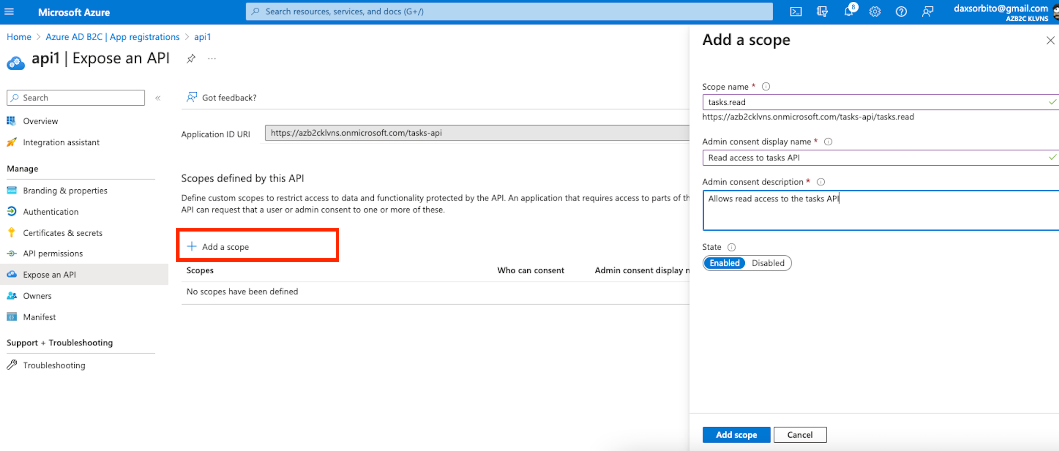

1. Add a scope `write` scope by clicking `Add a scope`. The following data was supplied on the `Add a scope` blade, and then click the `Add scope`.
   1. `Scope name` is `tasks.write`.
   2. `Admin consent display name` is `Write access to tasks API`.
   3. `Admin consent description` is `Allows write access to tasks API`.

### Grant permission for Web API

1. On the `App registrations`, select the created `Web App`.

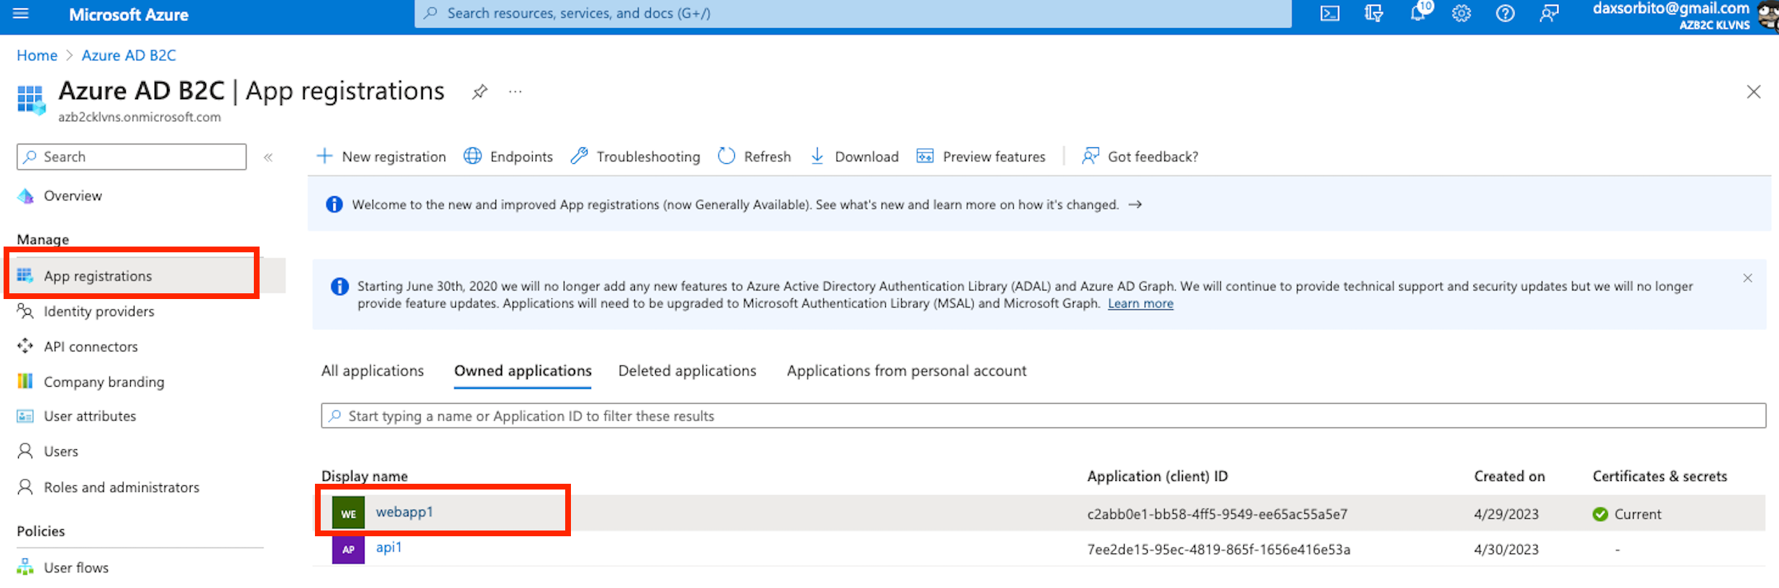

1. Click on the `Grant admin consent for AZB2C KLVNS`, then click `Yes`.

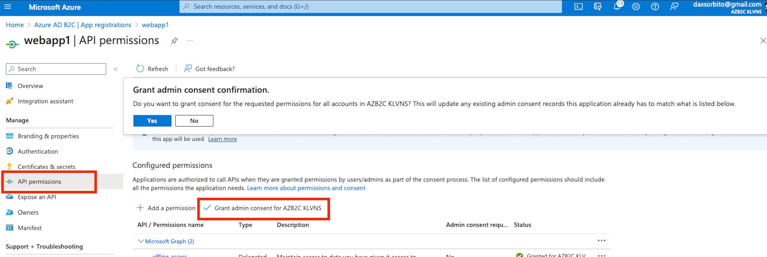

1. Click the `API permission` under the `Manage` menu, the click `Add a permission`

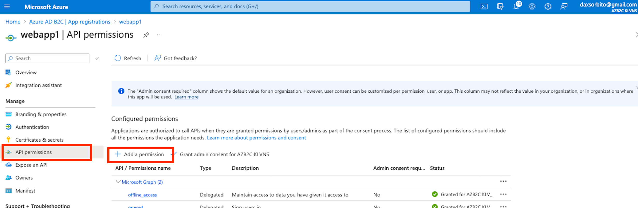

1. On the `Request API permissions` pane, select the `My APIs`, then select the created `App registration` for the API which is `api1`.

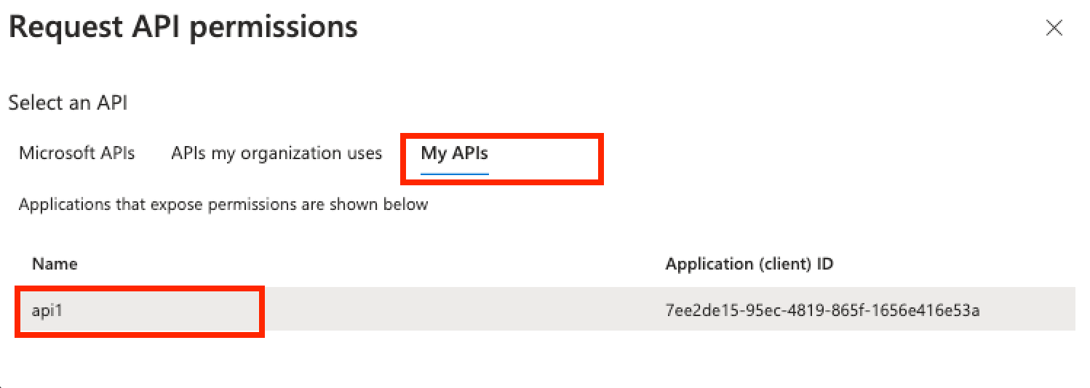

1. Select the tasks that was created earlier in the `Request API permissions` pane, then click `Add permissions`.

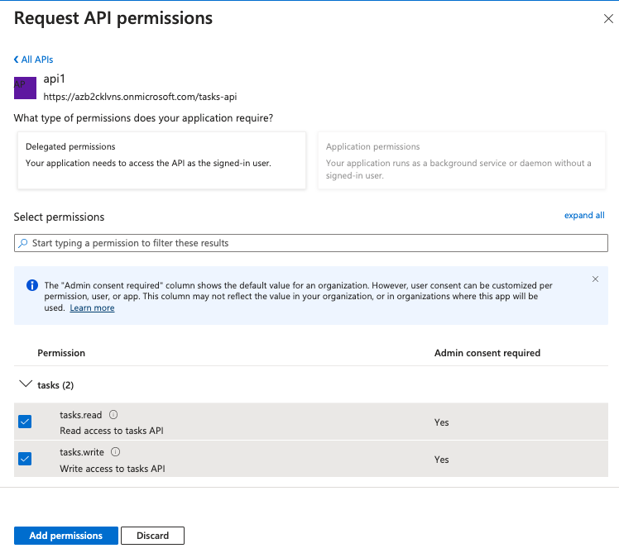

1. Copy the cope full name of `tasks.read`, to be used later.

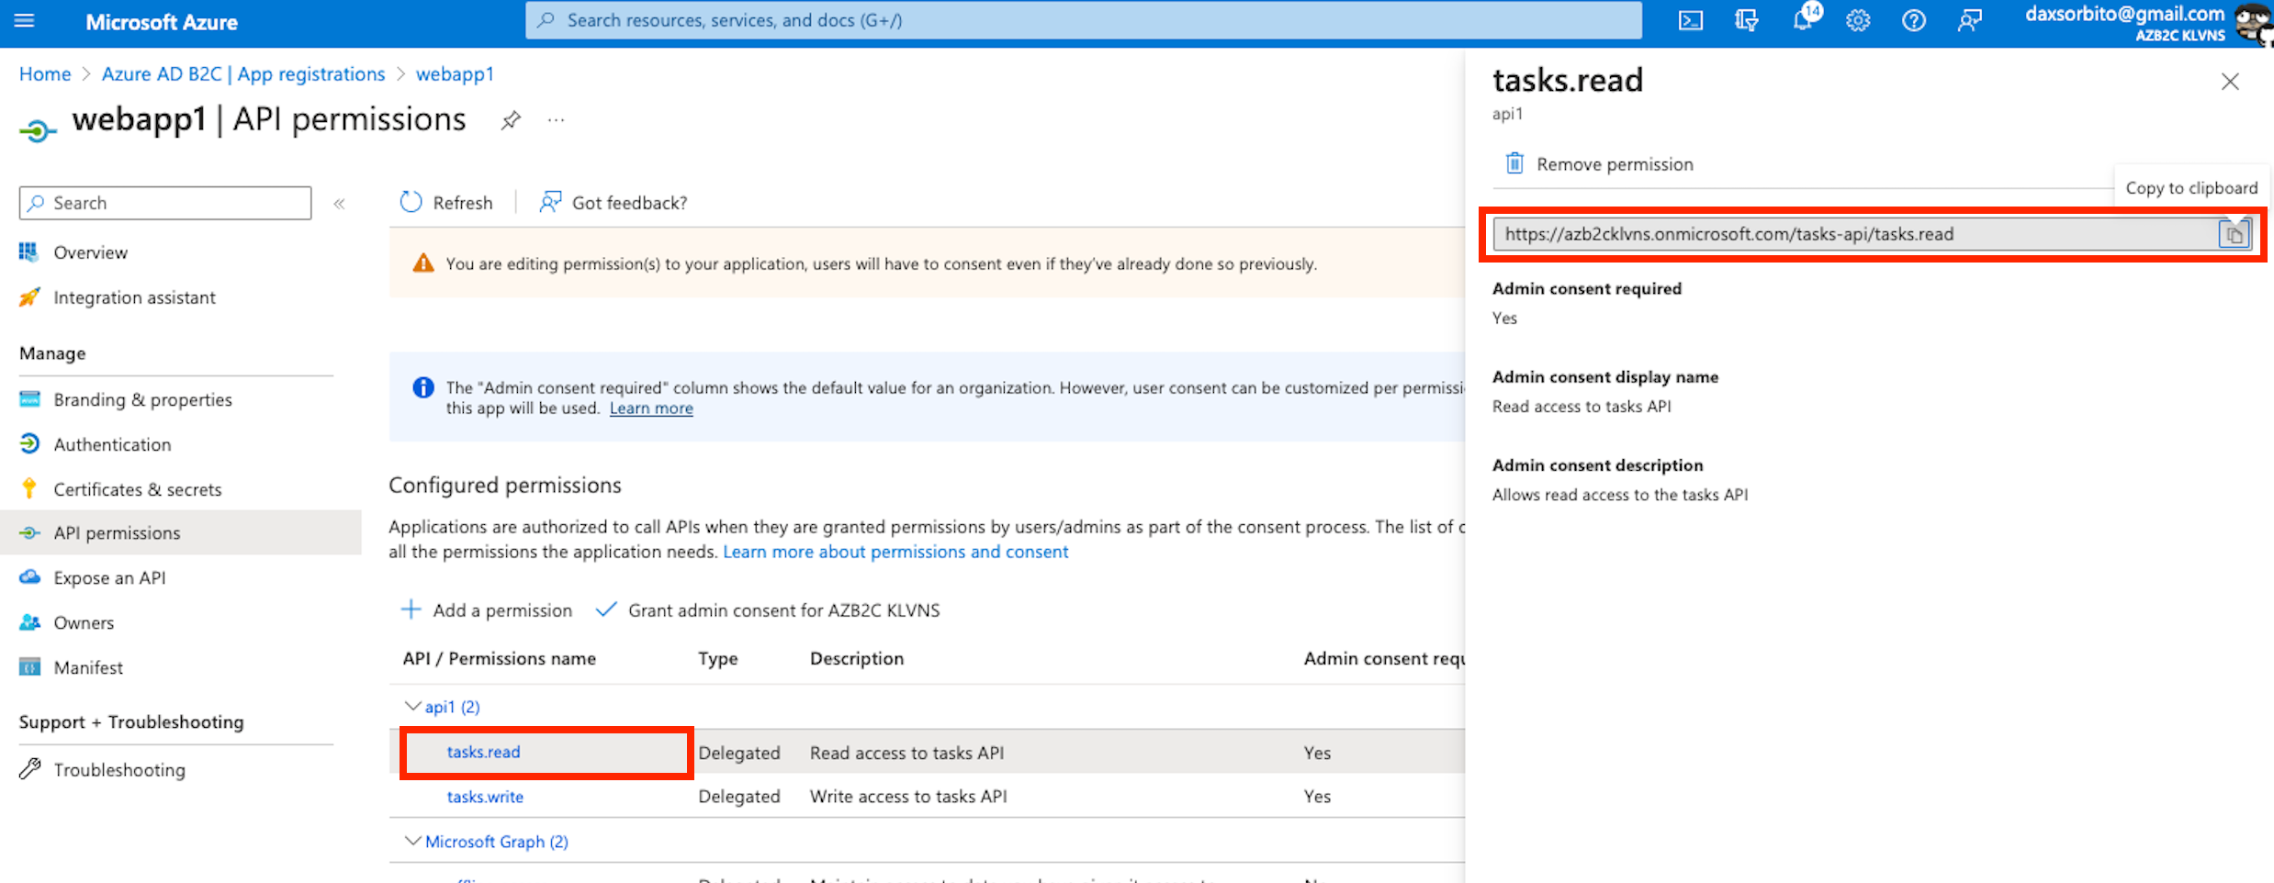

1. Do the same for the `tasks.write`.

## Running spike application locally

1. Clone the spike repo - `git@github.com:daxsorbito/azb2c_klvns.git`
2. Change the following on the `api/authConfig.js` file.
   1. Replace `<TENANT_NAME>` with the created AD B2C tenant name.
   2. Replace `<API_CLIENT_ID>` with API client id.
3. Change the following on `web/authConfig.js` file.
   1. Replace `<TENANT_NAME>` with the created AD B2C tenant name.
   2. Replace `<WEBAPP_CLIENT_ID>` with Web App client id.
4. Open a terminal, then `cd` into the `api` folder and run `npm install && npm update` then `npm start`, this would start the API application in `http://localhost:5000`.
5. Open another terminal, then `cd` into the `api` folder and run `npm install && npm update` then `npm start`, this would start the Web application in `http://localhost:3000`.
6. Open the `http://localhost:3000` in the browser.

## Testing the spike application

1. Once the application is running in browser, click `Sign in` and choose either `Sign in using Popup` or `Sign in using Redirect`.

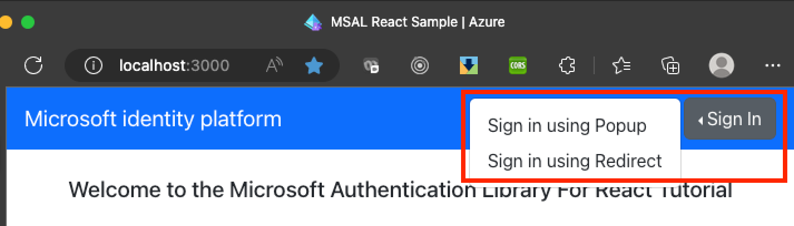

1. Click on the `Sign up now` on the `Sign in` page, a `User Details` would appear and follow the flow to register a new user.

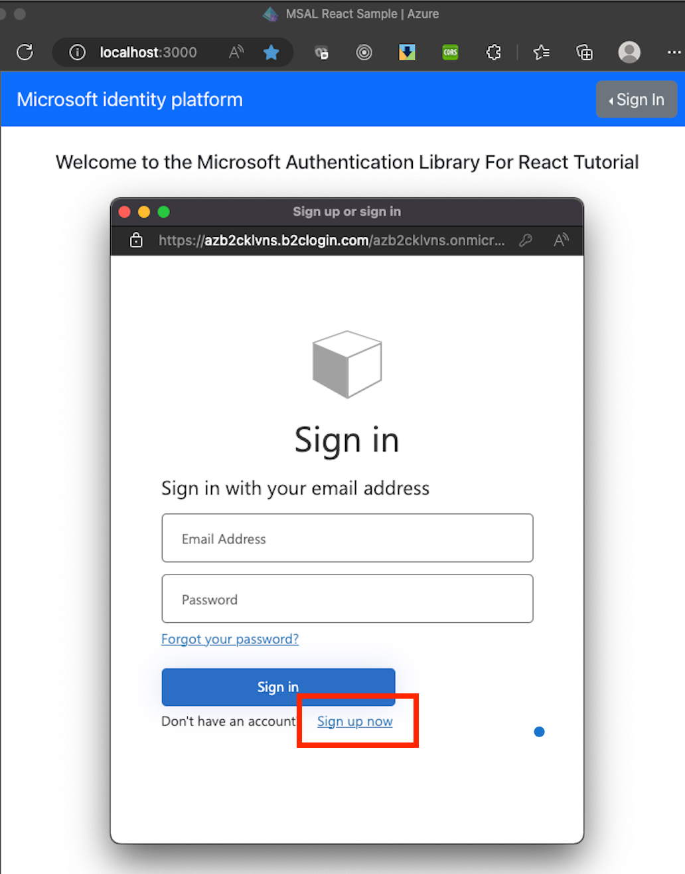 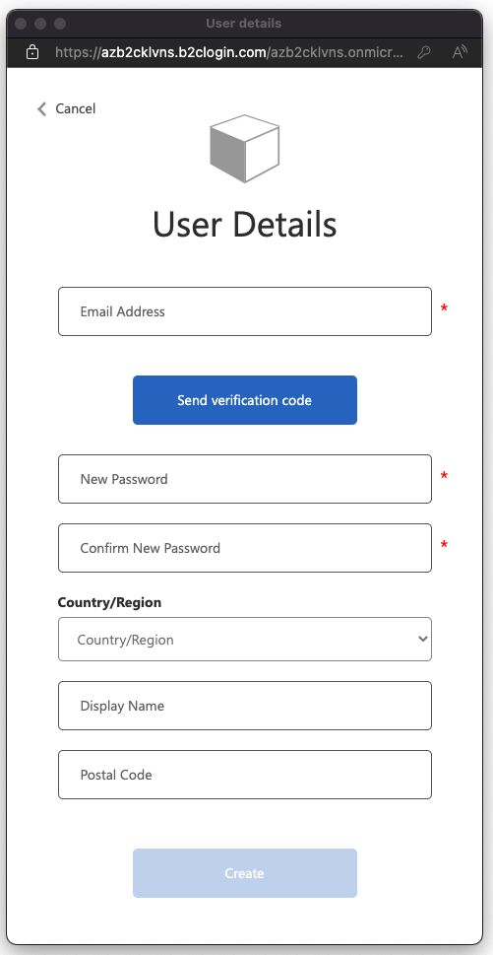

1. Upon registration or verification, you might receive an email same as below.

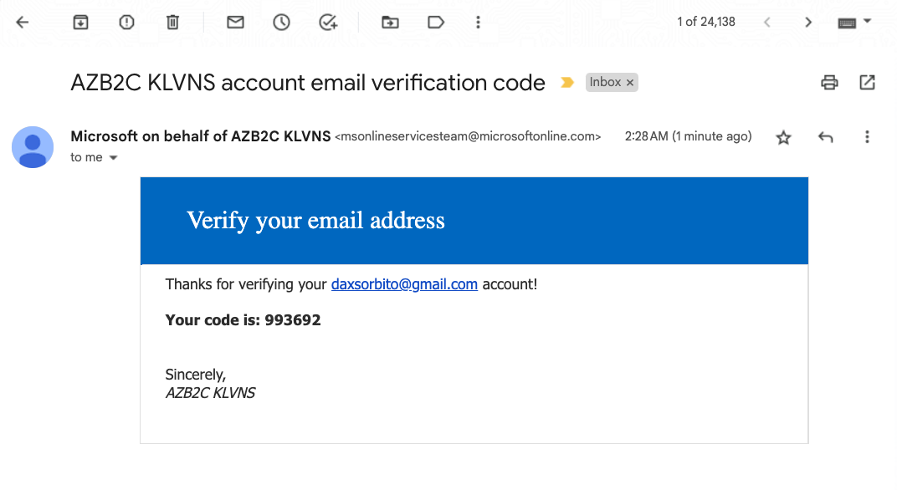

1. Upon successful login or registration, you see this screen. And click the `Todolist` link in the header to access the Todo list page that calls a AD B2C protected API endpoint.

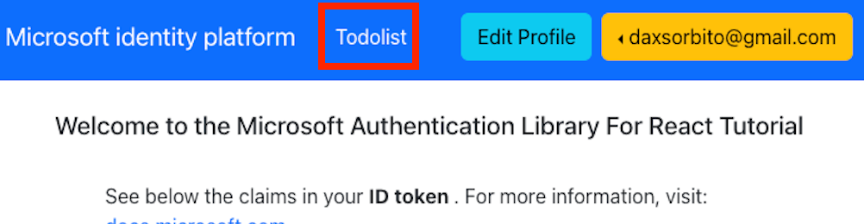

1. Below is the `Todolist` where you could `Add`, `Edit` and `Delete` a ToDo.

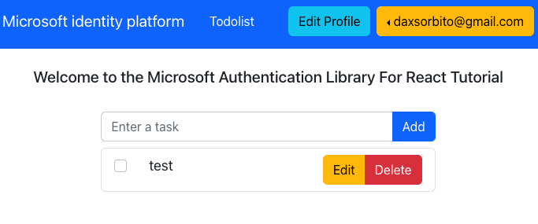

## Next steps

1. Create another identity provider, e.g. `Facebook`, `Google` or etc. This requires a developer account and configuration on each provider that would be configured on the AD B2C tenant.
2. Create a sample custom policy. This is a reference link that we could follow to implement this - [Tutorial - Create user flows and custom policies - Azure Active Directory B2C | Microsoft Learn](https://learn.microsoft.com/en-gb/azure/active-directory-b2c/tutorial-create-user-flows?pivots=b2c-custom-policy#enable-self-service-password-reset).
3. Change or customize the UI layout of either the user flow or the custom policy.
4. Deploy the infrastructure automatically by a pipeline – using terraform or bicep.